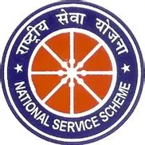

Report
Inaugurated by : Mr Bukum Doley (Assistant Professor)

Tiranga Rangoli Competition
(11.08.2025)
Indian Independence Day is celebrated on the 15th of August
Today, as we gather under the fluttering tricolor, we celebrate not just a date on the calendar, but the soul of our nation—India’s Independence Day. On this day in 1947, after decades of struggle, sacrifice, and unwavering courage, our country broke free from colonial rule and stepped into the light of freedom.
On the purpose of this special occasion NSS unit Mariani College, Mariani organised Rangoli making activity on 13 august 2025. Ten students participated in this activity. The competition started at around 1:00 PM to 4:00 PM. All the students had did a great work by making a beautiful Tiranga design. Program officer also took part in this activity The programme was successfully conducted at the college premises.

