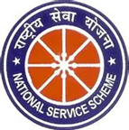

Report
Inaugurated by : Mr Bukum Doley (Assistant Professor)

National Sports Day
(29.08.25)

Today, we celebrate not just games and athletes—but the spirit of discipline, teamwork, and resilience that sports in still in us all.
"On this National Sports Day, let’s pledge to play every day, stay fit, and celebrate the champions within us. May the legacy of Major Dhyan Chand inspire us to strive for excellence, unity, and strength—on and off the field.”

Nss unit Mariani College, Mariani organised National Sports Day on 29 august 2025. The programme started at 12:00 PM onwards. We held Carro, Ludo and Chess tournament for the students at college campus. Before the tournament started firstly we held an ought pledge to be a best and play the game honestly. The tournament was conducted in two phase semifinal and final. We enjoyed a lot on this day and successfully ended at 2:00 PM.
