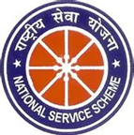

Report
Inaugurated by : Mr Bukum Doley (Assistant Proffessor)

MISSION SAHASI
(27.08.25 – 29.08.25)

Mission Sahasi is more than just a campaign—it's a movement of empowerment, resilience, and transformation. Core Message of Mission Sahasi are Empowerment through Action, Confidence & Courage, Practical Training and Nationwide Impact.

NSS unit Mariani College, Mariani organised Mission Sahasi a self defense training for the girls. This training is to protect ourself from any danger. Nss unit provides coach to train the female students. This training is for 1and half hours for 3 days each from 2:00 pm to 3:30 PM. The taining inspired and motivated every female students of the college and we get to learn a best thing that ever females needs to know now a days.

