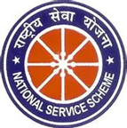

Report
Inaugurated by : Mr Bukum Doley (Assistant Proffessor)

Cleanliness drive
(1.09.2025)

Cleanliness is a very important thing in our day to day life. Whether it’s our home, workplace or public place, schools or colleges. It is one of the very basic needs of civilized lifestyle. Mahatma Gandhi gave the slogan “ Cleanliness is Godliness
NSS unit Mariani College, Mariani organised Swachata Hi Seva Hai (SHS) a cleanliness drive on 26th April 2025. The programme is held at the college campus. The campaign started at around 11:00 am. 20 volunteers of NSS unit took part in this drive. We have cleaned the college auditorium . The programme successfully ended at 12:00 pm
